**Page Object Model**

Framework - karana de lesiyan kara ganna puluwan wanna widiyata hada gana eka .

**2 Types** - Data Driven

Page Object Model

**Why -** Gmail hadanakota tebuna view eka dan change wela neh.Page eka button ekak teyanawa.eke element name eka change wenawa . eka test cases 10 teyanwa. E wage 20 places wala teyanawa.hama welawama hama thama change karanna wenawa neh .eka test case wala teyanne natuwa page class ekata aran yana eka thamai page object model keyanne.

**Page layer eke**

Elements locators

Click wage actions set eke methods widiyata da gannawa.

**Test layer eke**

Methods teka call karana eka thamai karanne.

Danne nati kenekta unath methods name teka order ekata teyana nisa test layer eke eyata idea ekak ganan puluwan e test ekan wena de gana.

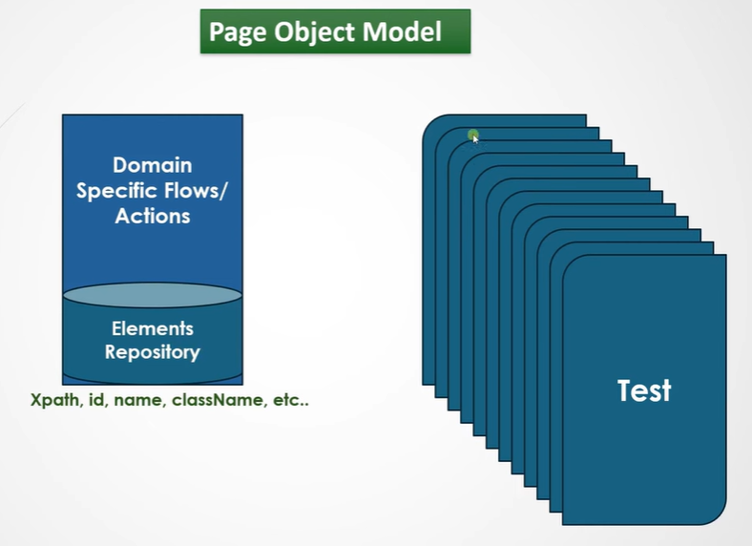

**Advantages**

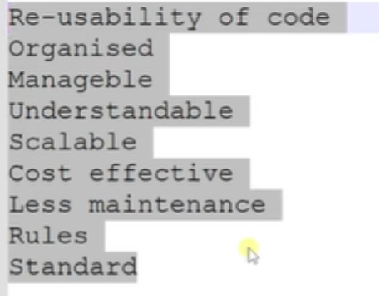

**Intelij**

New - project - java - maven

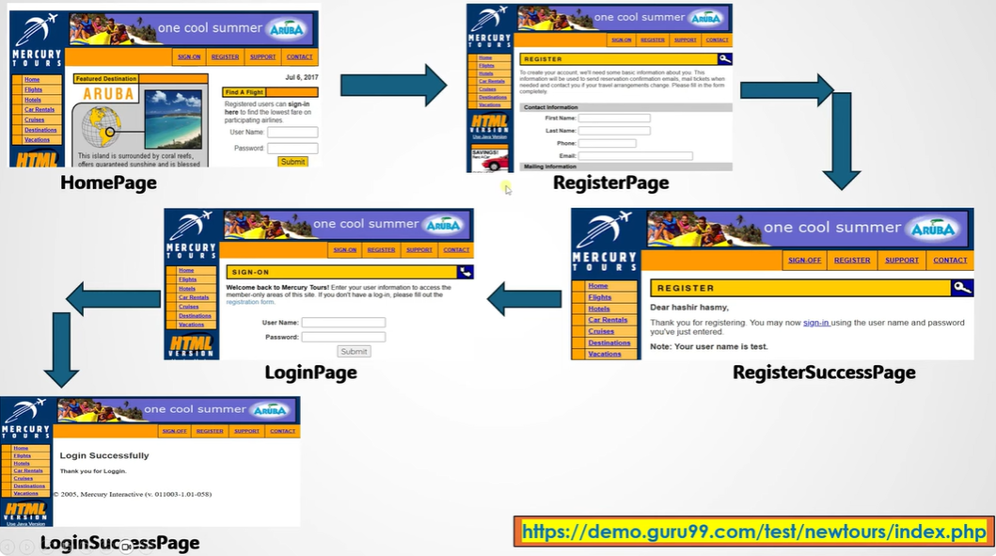

| Src - main - **Java** | Src - main - **test** |
| --- | --- |
| **Package -** pages - pages class - HomePage | Test class teka teyann ona methana. @ test annotation eka dapu method teyana class eka teyann ona test folder eka yatathe.  **Package -** testcases - TC001_RegsterUserTest |

TC001 - RegisterUserTest

Mulinma register menu eka click karanna ona neh

Main - java - pages-Homepage class - method ekak hadanna **selectregistermenu** keyala .

Meka athule neh driver.findelement keyala danna ona. But driver eke error ekak enawa neh.mokada driver eke initiate karala teyanne src - test - java keyala folder eke neh.(Test layer)

Eka nisa thamai **constructor** keyala ekak use karanne .

Thawa class ekakain me class eke teyanan method access karanan yanakota e class ekan object ekak hadanawa. Ethakota call wena method ekak thamai **constructor** keyala keyanne.

Eka class name ekanma thamai hadanne.void keyala return types na.dan constructor eka athulata webdriver eka pass karanawa.driver eka me home page hama thama use karana nisa eka global variable ekak wage da gananwa.

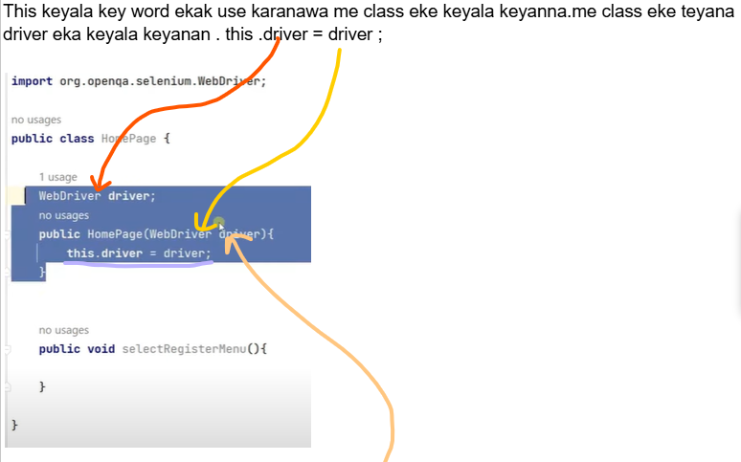

Me Driver eka thama power ekak na .make power eka teyanne @BeforMethod eka execute unata passe.

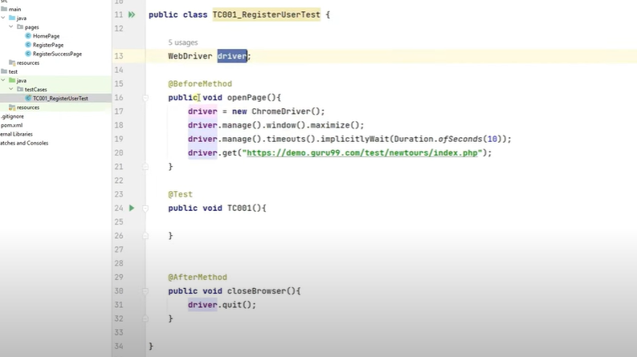

Me power eka api src-java-pages wala teyana constructor ekata pass karanna ona.ekata thamai constructor eke argument ekak dala teyanne webdriver driver keyala.

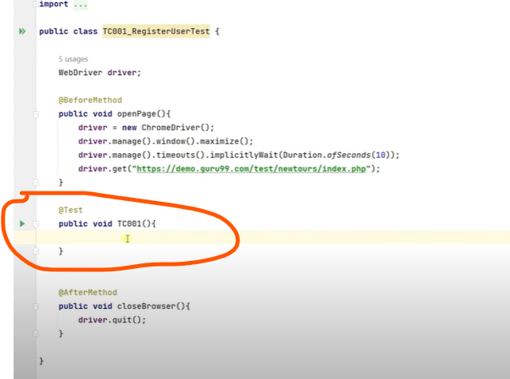

Me method eke edala home page ekata object eka hadanakota api constructor eka call karanawa.ethkoata driver ekata power eka enawa.

By.LinkTest meka class athulata giyama crtl eka click karanagana **By** keyala thamai return type eka teyanne.By.LinkTest(“Register”) eka By ekata store karanna puluwan.

Driver.**findElement** - me method ekan thamai **element ekak find karanne**

**By.LinkText(“Register”)** - meka thamai locate karanne element eka .

Element eka find karana ekai locate karan ekai 2kak.

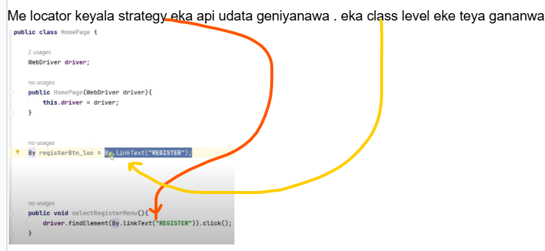

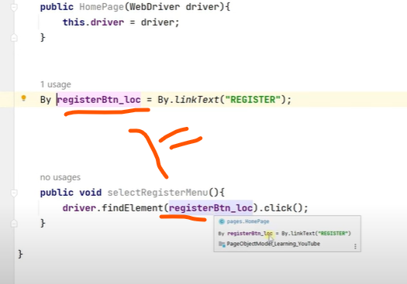

Src- test-java

@Test method eke

Public void TC001(){

Meka home page eke object ekak hada ganna ona

HomePage homepage = new HomePage(); - new ekata passe call karanne e class eke constructor ekata

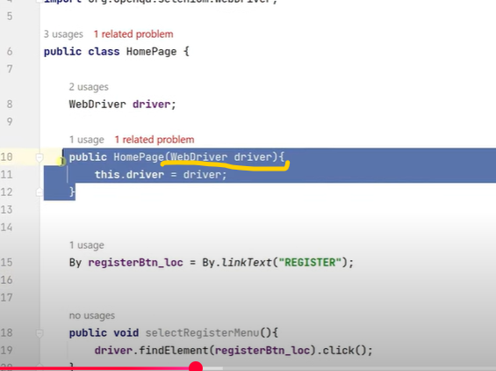

Meka webdriver driver keyala argument ekak pass karala teyanawa.e argument ekata haryana widiyata value ekak pass karanna ona .driver eka pass karanna ona.

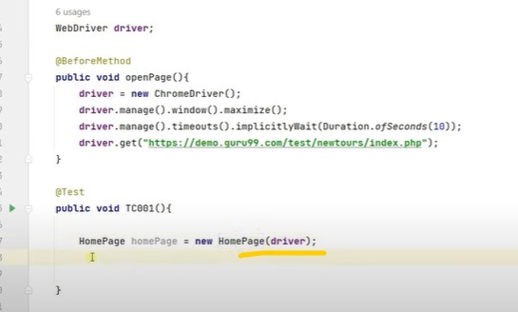

Dan me driver eke power eka home page ekata giya

}

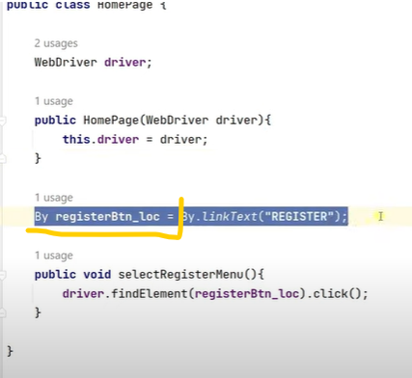

By eke neh meka store kare.mata test class edala action ekak karanna ona keyala hithanna.

Ethakota karanne HomePage homepage = new HomePage through apita eke methods access karanna puluwan neh.eth By registerBtn_loc = By.LinkText(“Register”) meka access karanna ba neh .ekata karanne teyanne access modifier ekak dana eka .Public keyala

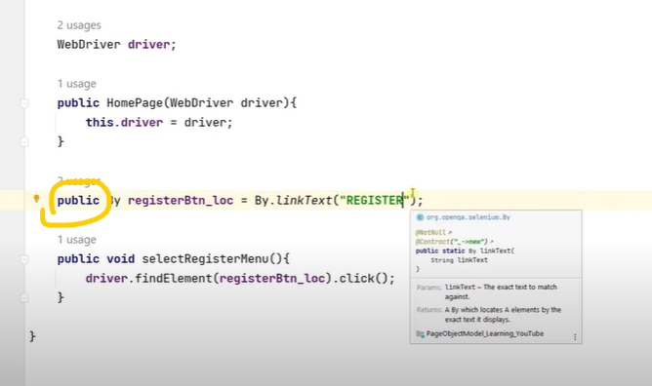

But hoda widiya thamai below eka

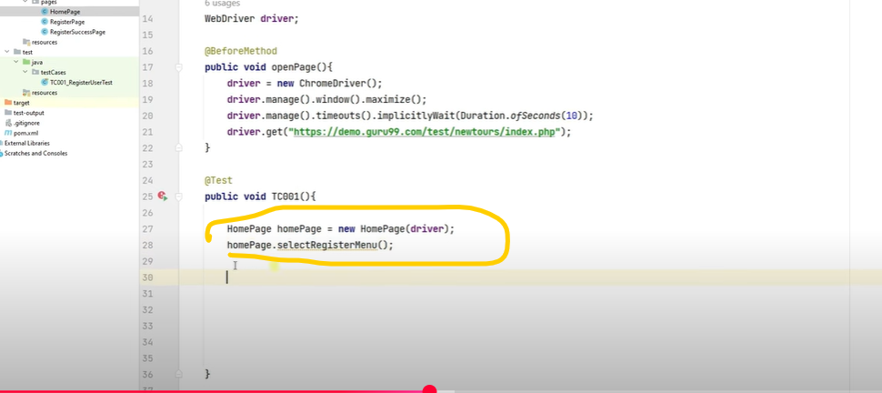

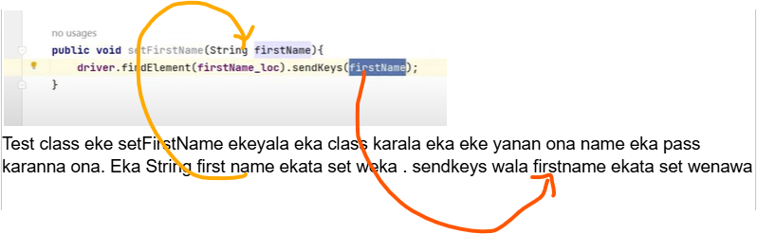

Drop down eka handel karanne

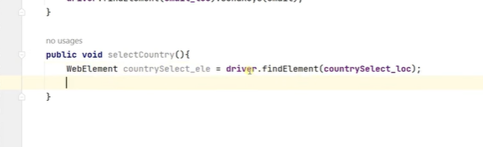

Me WebElement keyala eka gaththe findelemet eka CRTL ekath ekka click kara la return type eka bala eka dala name ekak danna.

Me leemet eka find karan inne thama .meka dan locate karanna ona. Drop down ekata option ekak select karanna teyanne dan.

DOM eke gehen balanan select tag ekan da drop down eka teyane ekyala . etahkota selenium wala class ekak teyanwa select keyala ,eka dala ganan puluwan.

Select dropDownCountry - new Select(methana pass karanna ona api allapu element eka value eka )

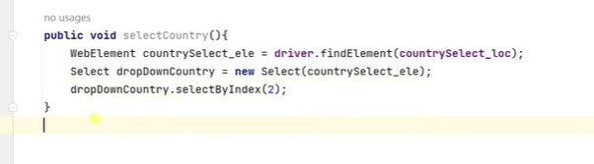

Xpath liyanakota ‘’ danna mokada By.xpath keyala danakota “” athule neh danne.ethakota error ekak enawa



findElement return karanne interface ekak

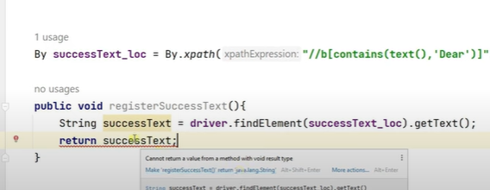

Return kaanna ba. Void neh teyanne . eth api string ekak return karanawa neh .

Meka nkn api lamayk salli dila tea ekak gannat danna kiuwa wage - void

Lamayekta salli dila chocolate aran kanna kiiwa wage - return type ekak dana eka - string

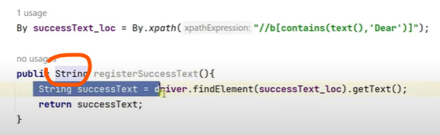

Assert karana widiya

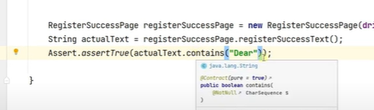

actualText keyala method ekan return karanne boolean ekak

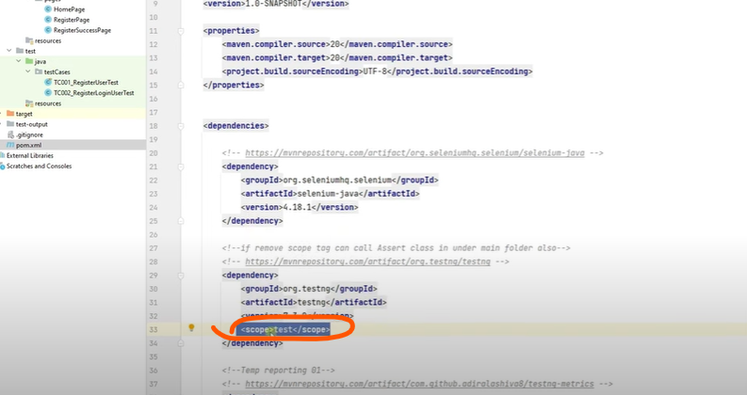

Mekan keyanne src - test - java eka teyana assertion wethak ganan keyala . nkn hari main java eke assert karana ewa error enawa . (Pages class eke danan puuwan)

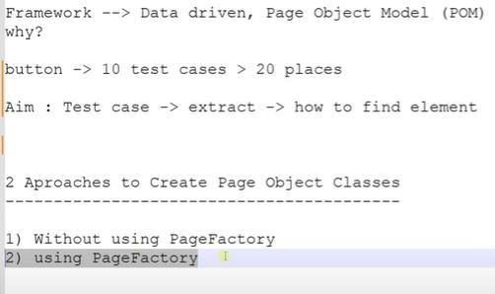

**POM - Using PageFactory**

driver.findElement keyana ekan neh element ekak identify kara ganne.eka natuwa wena widiyak teyenawa.element identification ekai element locate karana ekai 1 place ekakin karanna yanawa dan api.

Public - meka da gaththama me class ekanobject hadawama ona thanakin access karanna puluwan.

Driver.findelement return karanne webElement ekak neh . eka nisa element eka identify karama eka store karanna puluwan webElement eke.

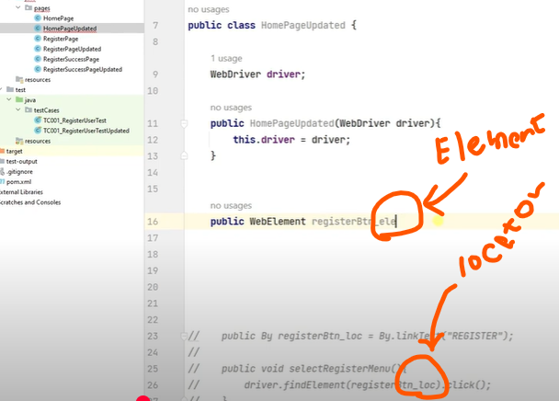

Pubic WebElemebt registerBtn_ele;

Dan meka element eke location strategy eka ko. Dan me element eka alla ganna widiyak na neh.eka prasnayak neh.api webElement ekata variable ekak haduwa registerBtn_ele keyala. Dan me element eka identify karanna apita teyenawa annotation ekak.@ keyala dala balanna

@FindBy - Selenium walin thami meka enne.

Mekata api arugmented ekak widiyata pass karanna ona **how** key word eka.

Thawa teyenawa **HOW** keyala enum class ekak

(how =How.locator teka enawa,using = “ape value eka”)

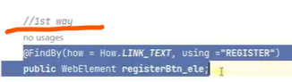

Lesi widiya thamai below eka

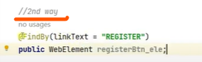

Dan registerBtn_ele eka method eke nknma call karanna puluwan.me registerBtn_ele eke . ekak tebama eka webelement ekak nisa . webElement class eke teyanan ona method ekak options widiyata denawa.

Me registerBtn_ele value eka enne @FindBy ekan api element eka identify karagana neh teyanne.

Driver eka use karala neh kare . me @FindBy ekatath driver eka ona. Api me driver eka koheth use kare na neh ..ekata thamai **PageFactory** class eka use karanne.eke teyenawa **InitElements** keyala method ekak teyenawa.eka pass karanna ona class ekata hadana constructor eka athulema thamai. Ethakota thamai me class ekata object ekak hadanakota me line ekath execute wala ape element identification ekata power ekak enne.

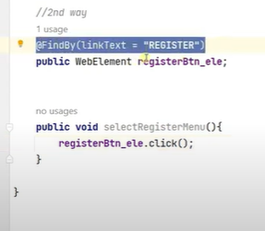

**InitElements = Intiatize element** - meka athule argument 2kak pass karanna ona

1st argument - ape driver eka

2nd argument - mona class eke teyana elements da capture karanna ona. Eka nisa driver. Keyana eka hama thanama use karanna ona na.

Apita ona HomePageUpdate keyala class eke teyanna elements teka thamai me driver eka use karala identify karanna ona.ethakota me class eka keyala pannaa apita java wala this keyala key word ekak teyenawa. Eka use karanna.

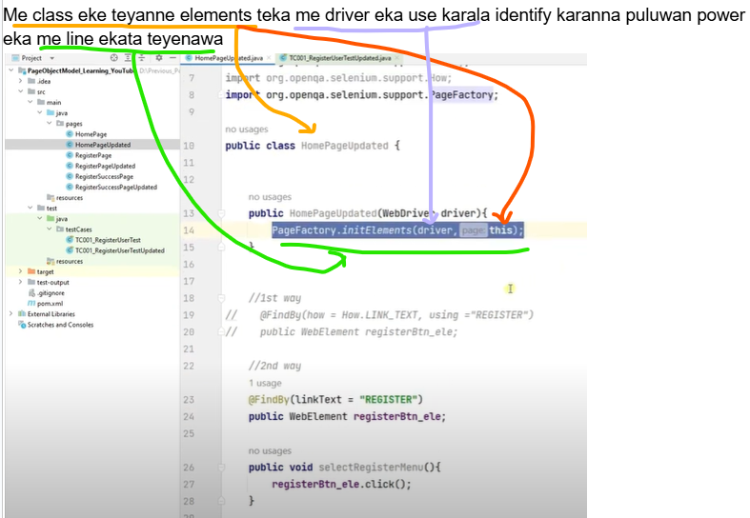

Meka nisa dan driver.findelemet eka hama thama use karanna ona na.api constructor eka thule

PageFactory.initElement(driver,this); eke pass karama athi.api gawa @FindBy dala element 100 tebunath power eka yanawa me driver eka use karala element eka identify kara ganna puluwan.

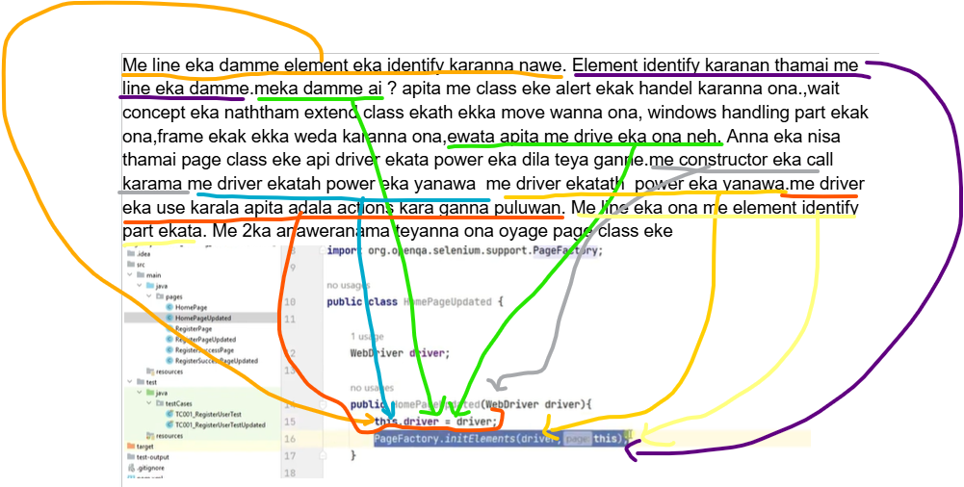

***\*\*\*\* Page class \*\*\*\****

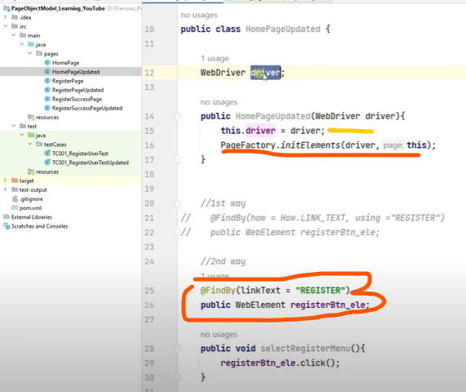

**Dropdown handle**

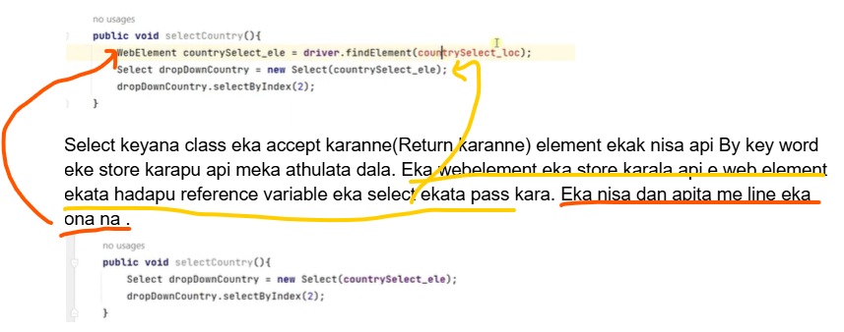

Pagefactory ekai this.driver ekai commnet ekarala error eka balanna.

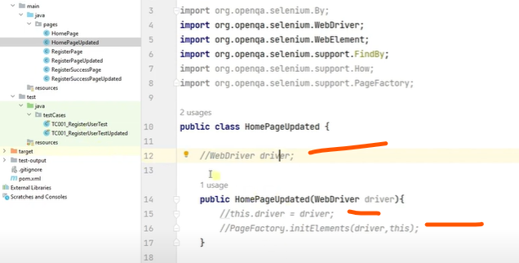

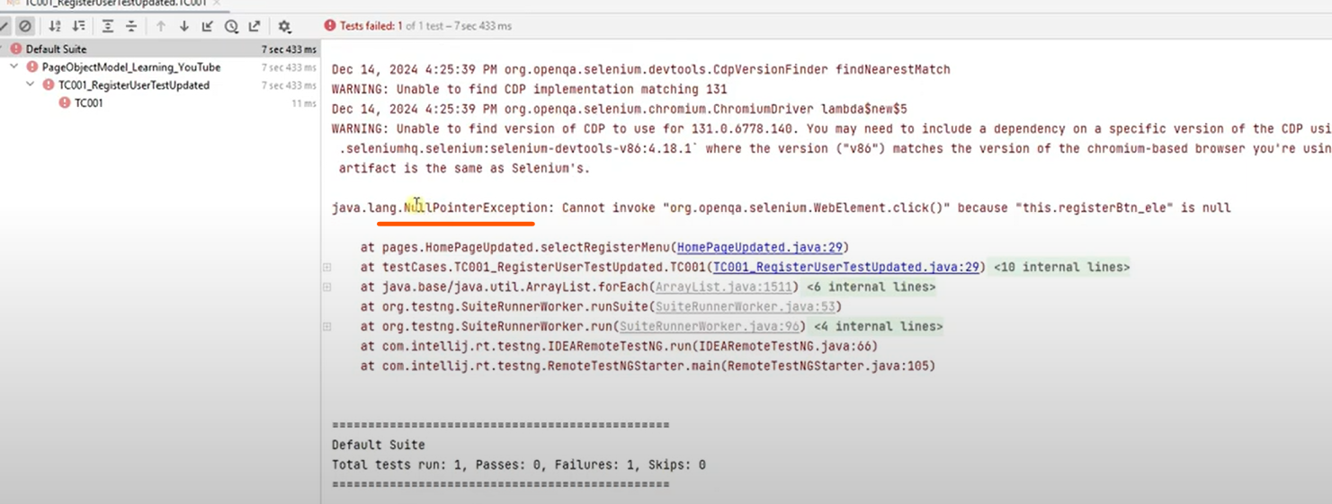

**Interview Question**

Login functionality eke automate karanna findElemets use karanen natuwa ?

Ethokota page factory use karala karana hati keyanan ona.

@FindBy(xpath,”//xpath”)

WebElement name;

WebDriver class eke findElemebt method eka wethak nawe neh teaynne. Eka nisa thamai this.driver= driver da ganne.

Class ekan object ekak haduawama mulinma call wanne constructor eka .eka thamai mulinma execute wanne . eka nisa thamai pageFactory eka constructor ekata da gaththe.

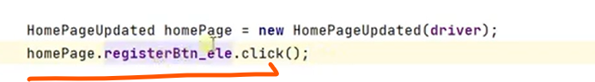

Page class eke methods hadanan natuwa me widiyata test class eke dagana yannath puluwan

Test case eke **readable** eka wadi karanna puluwan below wage dala

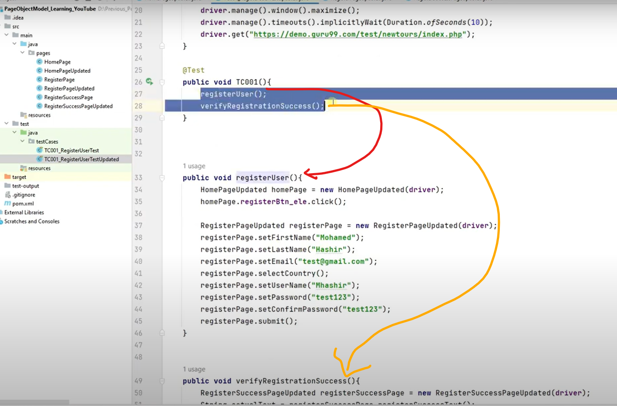

**Reusable** eka wadi karanan puluwan below wage

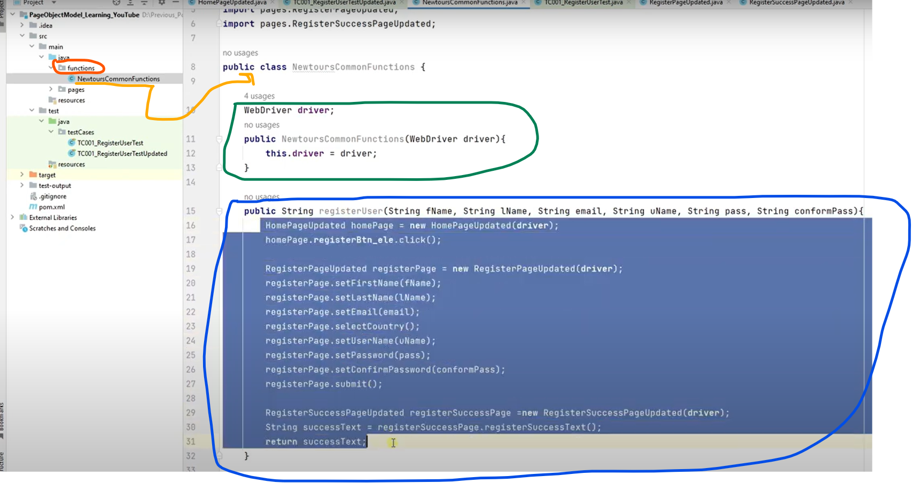

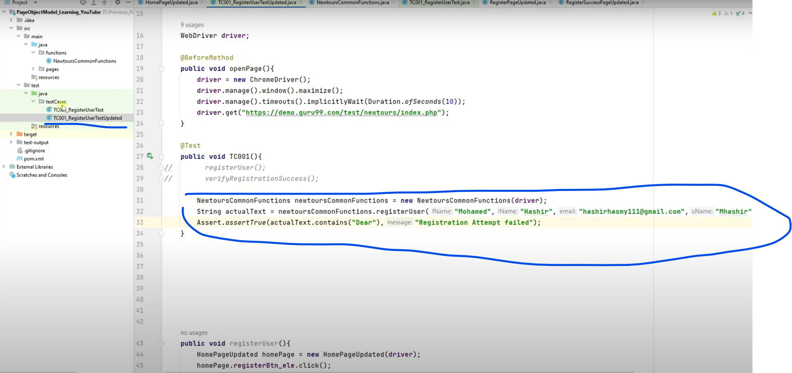

**Method Chaining -** Java concept ekak selenium concept ekak nawe

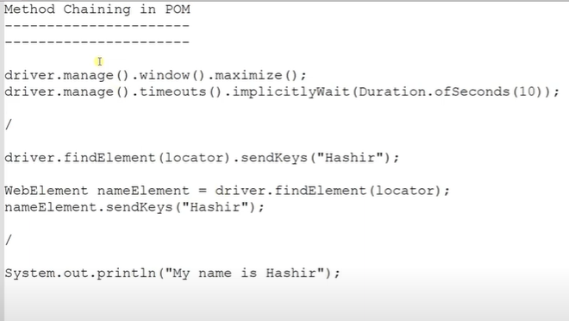

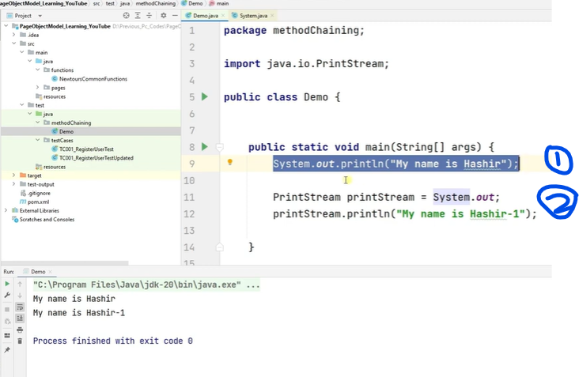

Me option 2kanma wanne ekama de . me PrintStram keyanne out keyana eka return karana return type eka . meka gaththe out keyana eka crtl+space karala athulata gehen.meka wedak nati wedak nneh eka line ekan ganan puluwan eka lines 2kakin ganan eka.

Method chaining - hugak walawata use karanne API automation wala.

**Getters ans Setters**

Test - java - java class ekak hadanna main method dala

Eke variables 2kak hadanna

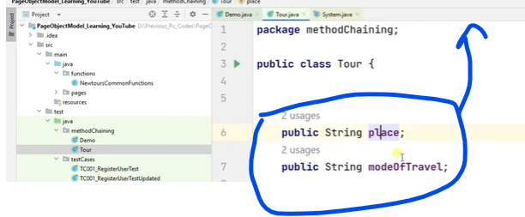

Class eke right click karala.

Generate - (Encapusulation)getters and setters select karanna.ethakota variable 2kata hada ganan puluwan.

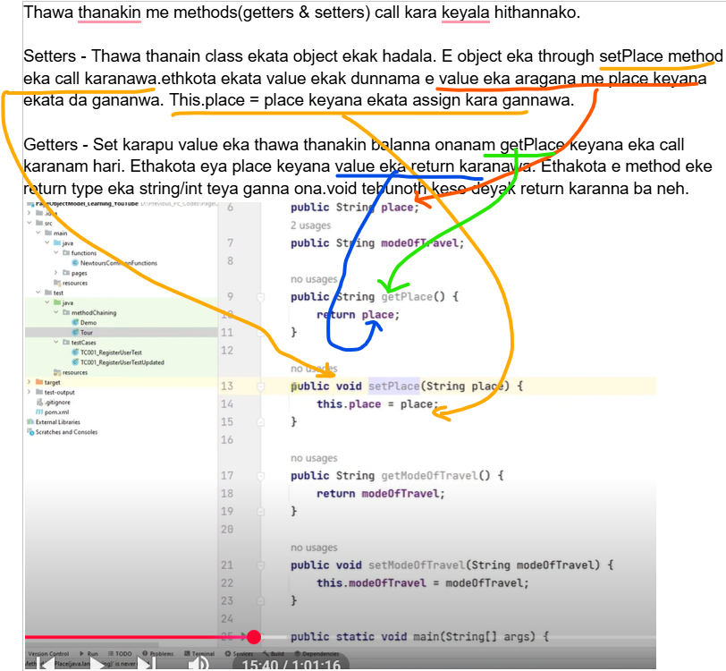

Yaluwo set eka ekatu wela trip ekak yanna hithan innawa . api place eka widiyata nuwaraeliya select karan innawa.modeof travel = car eka yanna ona keyala hithan innawa.yanan onan menna teyana ekenek ahanawa koheda api yanne keyala.e prasneyata answer ekak dena widiyata api method ekak hadamu.eyata api answer eka pahatha widiya denawa.eta passe eya apita answer ekak denawa neh . eka apita danawa ohh athal eke car eke nuwara eliye yanawada keyala

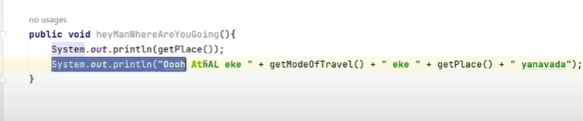

Eta passe eka main method eke call karanawa.

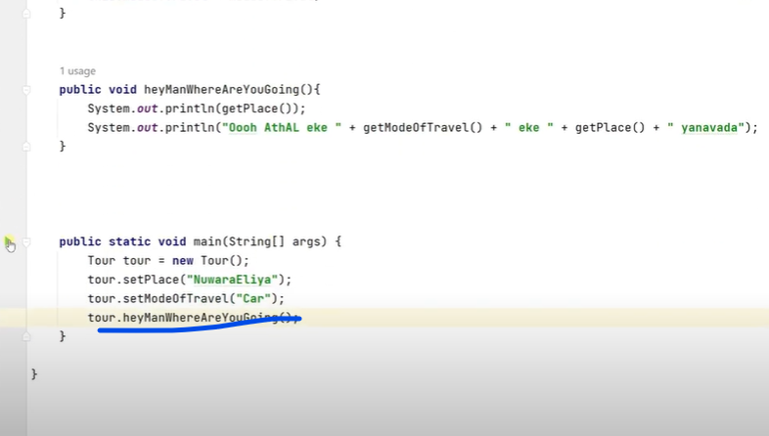

Main method ekan me tour keyana class eka object ekak hada gananwa.ethkota thamai variable and methods access karanna puluwan wennne.

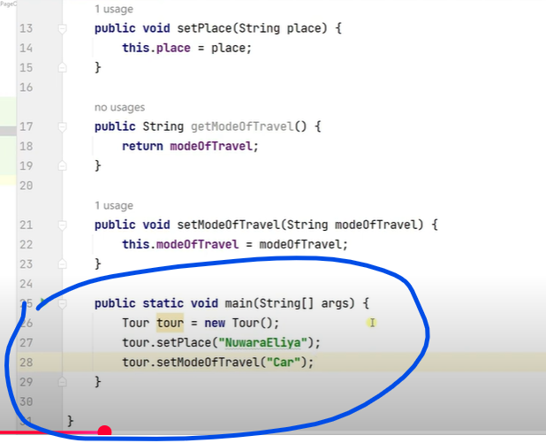

Tour tour = new Tour(); - me tour keyana ekata object eka widiyatath , reference variable ekak widiyaath ganan puluwan.

Dan me lines teka adu karala optimize karanna yanawa.

Public void setplace(Sting place){

this.place=place

}

Meka void ain karala class eke name eka danawa,

Eta passe error ekak enawamissing return statement enawa

Ethanata return this keyala danwa . mekan wanne me class eke object eka return karanan keyala .

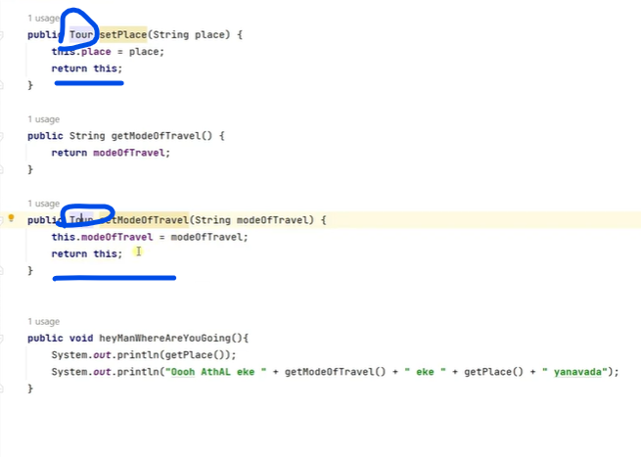

Dan class object eka return karana nisa method channing denawa .void teyanwakota . dammata mukuth panne na . dan enawa class object eke return karana nisa.dan class eka athule teyana variable + methos okkoma pannawa.

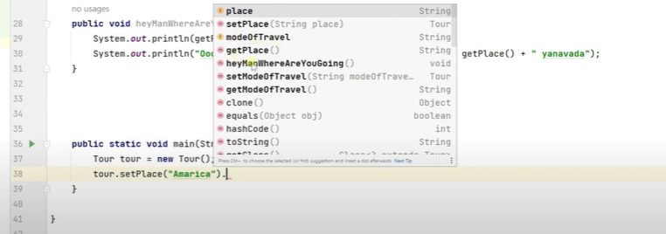

Heymanwhereareyougoin eka dala . tebbata mukuth enne na.eke void neh teyanne . eka nisa e method eka teyan ewa ganan ba.

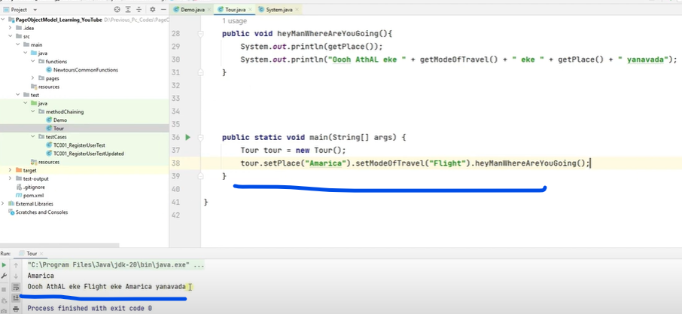

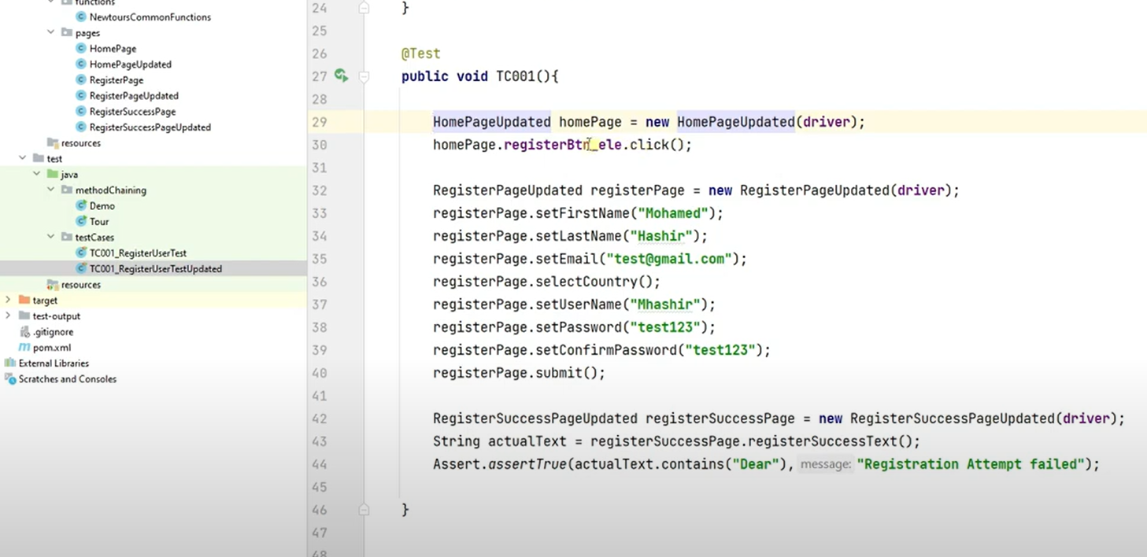

Mekata api method channing da gannawa.

Api dan home page eke innawa . Register button eka click karata passe mama yanne mona page ekatada ? register page ekata neh .ethokota return karanna ona home page eka nawe ai yanne register page ekata nisaeka thamai danna ona . ethota e class eke object ekak hadala thamai rerun karanna ona.

Ethokta error rkan enawa argument ekak missing keyala. Eka athulata gehen balanna mokakda return karanne keyala .driver eka neh.ekata driver eka danna . api me new dala call karane constructor ekata neh .eka passe error ekak denawa return type eka change karanna keyala

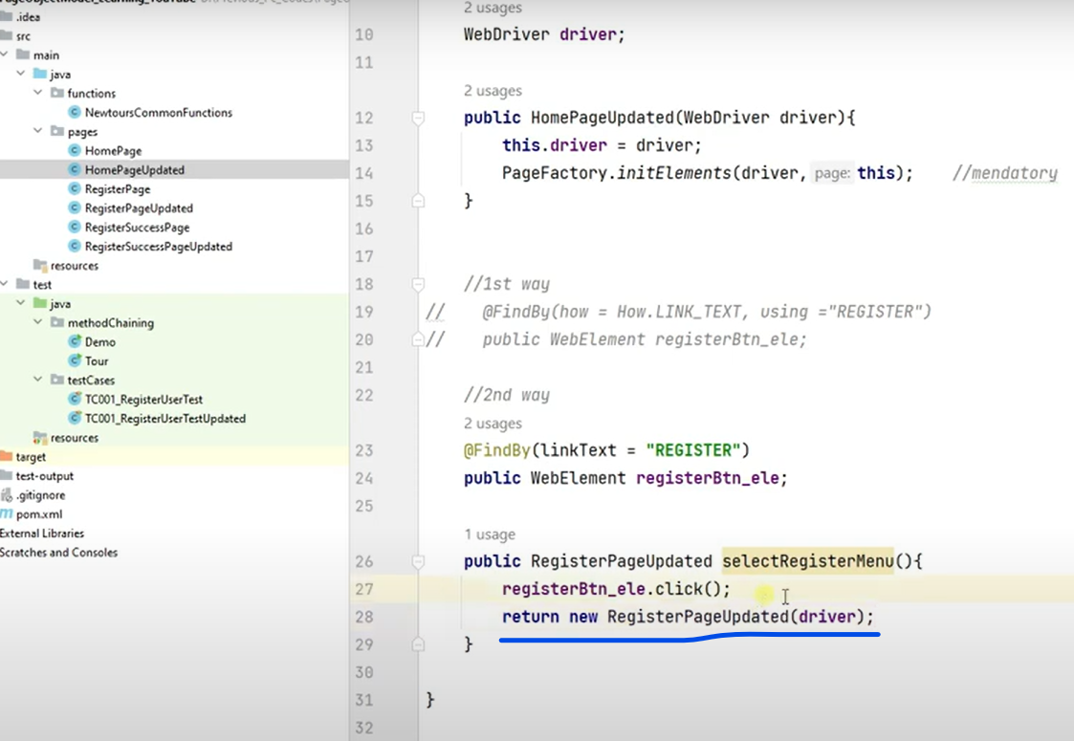

Meka next ekata yana class eke object ekak haduwe eke variables and methods use karanna puluwan wanna.

Eta passe register page eke return karanna ona me class ekama neh . eka nisa return this danna ona.

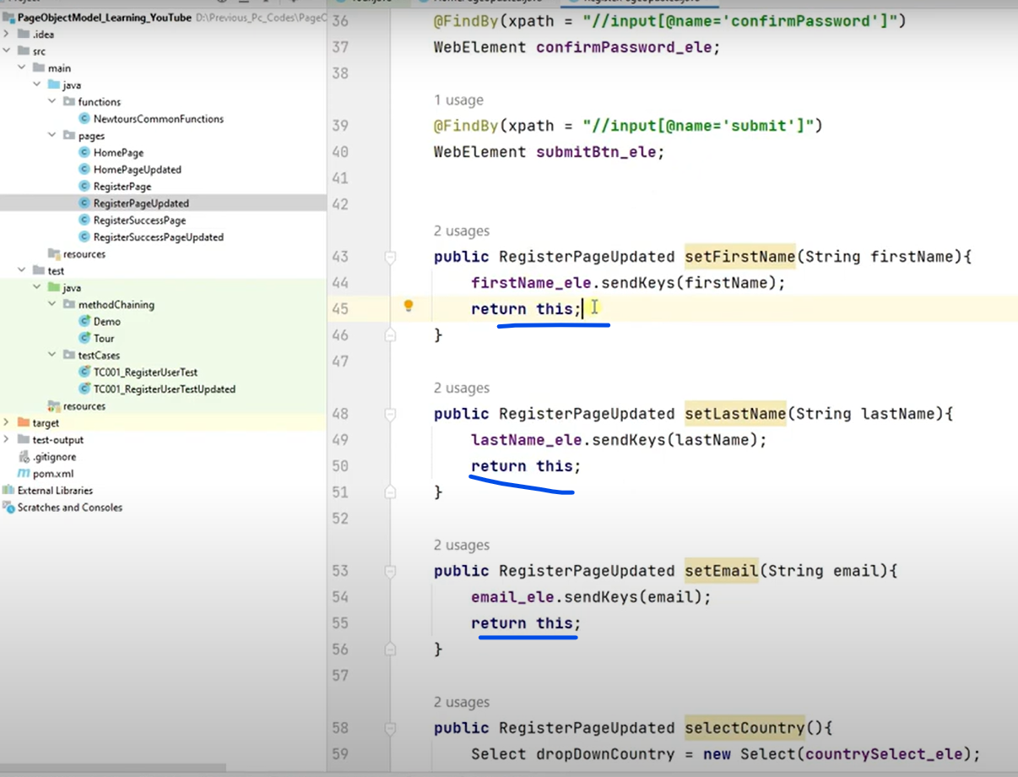

Submit eka click karata pass register success page ekata.ethkota return karanna ona next page eka (regstersuccesspage eka) eka object ekak hada ganna ona

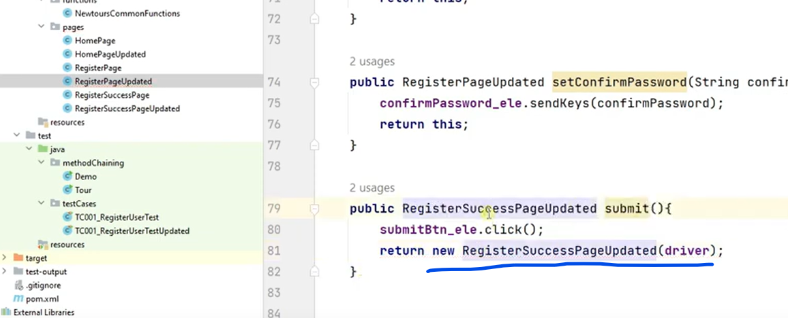

Dan yanna last class ekata . register success paga keyana ekata . eke success test ekak neh enne eka string ekan return karanna dala teyenne.

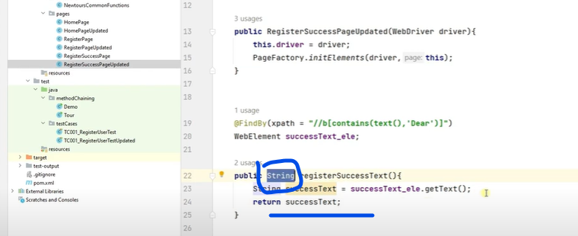

Dan test case ekata yanna.

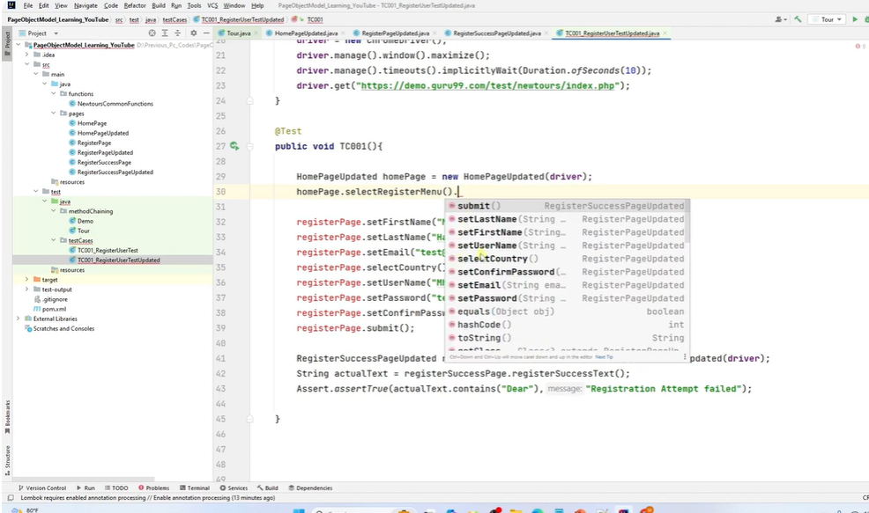

Dan wena wenama objects hadanna ona na. Method chain karala teyana nisa . teyala ganna puluwan.

; remove karanna naththam ethanin stop wenawa.

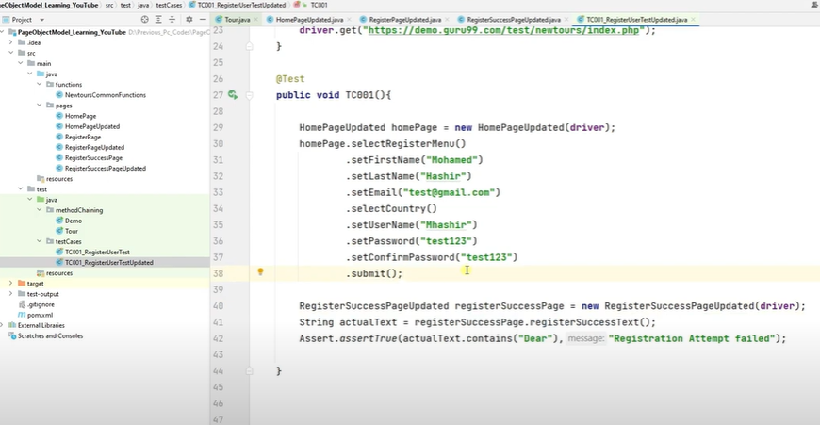

selectRegisterMenu eke registerpage keyana eke object eka return karana nisa eka danna ona na.

Below eke return type eka string ekak.

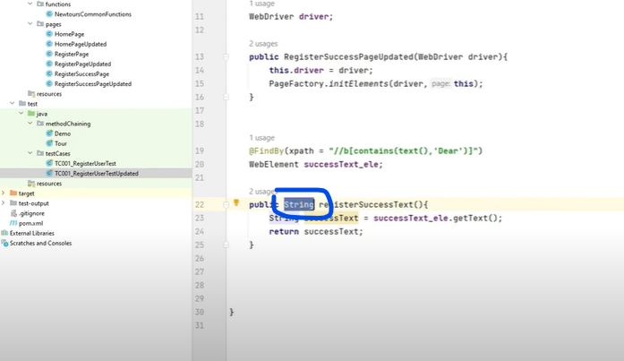

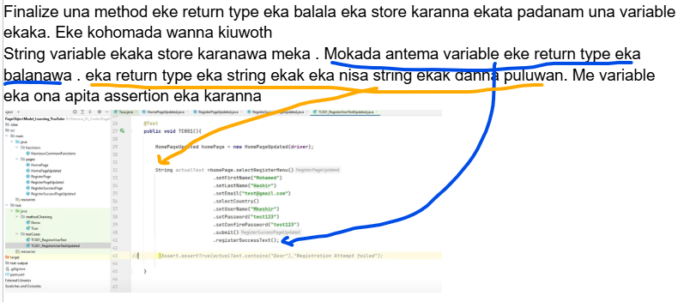

***XML File***

Project - new- directory- xmlPlans

XmlPlan - new -file - QA_Reg_ModuleA_Plan1.xml

_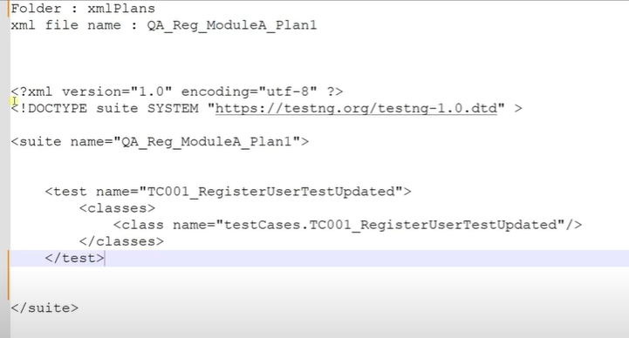

Eka test ekakin eka test ekak cover wana widiyata thamai dala teyanne.

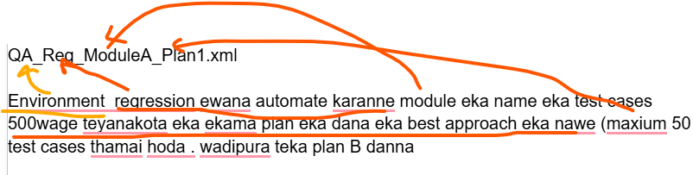

XML eke suite name ekath file name ekamai dunne

Class name eka - testcases folder eka teyana eka - testcases.tecname eka

Test name - class name eka dala teyana test case name eka

Dan xml file eka run karanna. Test eka pass wai.

Apita dan report ekak ona. Eclipse walauam report ekak enawa xml file ekan . but interlij eke na.

Testng walin apita report ekak denawa . eka da ganan puluwan.

xmlPlans eke teyana xml right click karala - modify run confighration - listerner tabe - + eka click karala. Eka email keyala search karanna - ok

Testng listener ekak use karala me xml eka run karamareport ekak enawa .